**2016 WACE Exam**

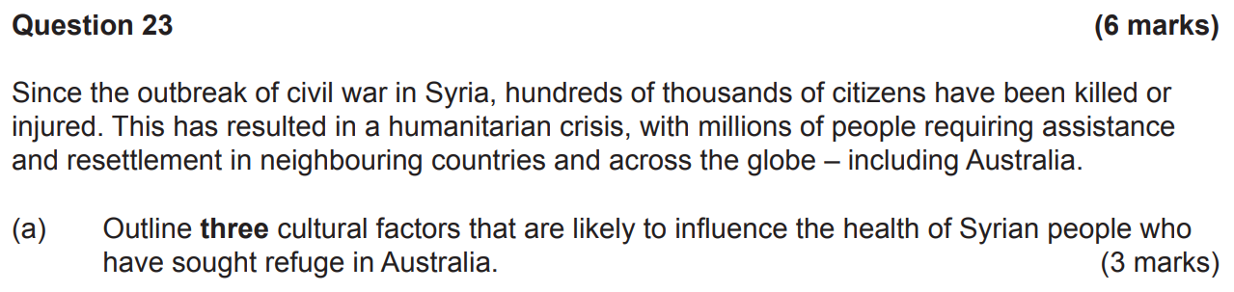

* **Influence of prevailing cultural values and beliefs e.g., honour which could result in refugees ignoring potential health concerns where there’s stigma e.g., drug addiction and mental illness which could bring shame to their family.**
* **Influence of the role of the family and/or friends and how they view illness or disease and treatment e.g., traditional gender roles with respect to pregnancy.**
* **Influence of the way the culture perceives death.**
* **Acceptance or non-acceptance of preventive health measures e.g., screening and vaccinations could be influenced by differing attitudes to healthcare.**
* **Influence of how the culture interacts with healthcare professionals e.g., whether they’re open and willing to discuss symptoms/illness.**
* **Perceptions of the Australian healthcare system and whether it can adequately support the needs of refugees.**
* **Reluctance of people to seek access to healthcare due to language barriers.**



**Newly arrived refugees may not have sufficient social networks/support which could result in:**

* **Increased likelihood of depression.**
* **Greater susceptibility to chronic illness e.g., heart disease.**
* **Greater susceptibility to bouts of sickness or greater recovery time.**
* **Greater susceptibility to stress which could cause health problems or worsen existing health problems.**
* **Decreased levels of happiness or overall satisfaction with life.**
* **Feelings of lethargy, fatigue or poor energy.**
* **May result in harmful substance use/addiction.**



* **Check where the research is published. Research published in peer-reviewed journals are generally subject to more rigorous scrutiny than media sources.**
* **Check the date of publication to ensure it’s current.**
* **Check the credentials of the author to see if they’re well-regarded or could be biased.**
* **Check whether the findings of the research are consistent with other research.**

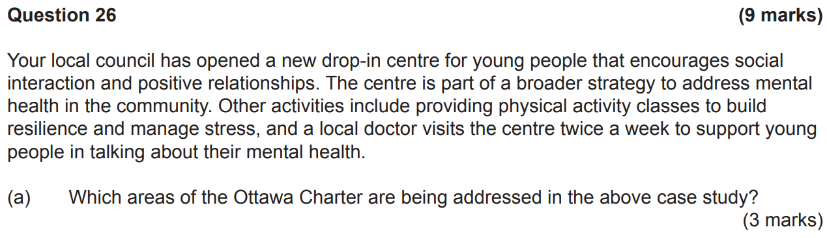

* **Creating supportive environments.**
* **Developing personal skills.**
* **Reorienting health services.**



**Enabling: Supporting others to help them develop skills and capacity to take control/power over the factors that determine their health.**

**Strategy: With respect to mental health, young people could be encouraged to participate in programs that improve their coping mechanisms.**

**Mediating: Coming to agreement and negotiating a common goal.**

**Strategy: With respect to mental health, mediation between groups/agencies to ensure cooperation where common interests exist e.g., partnerships could be encouraged between groups/agencies that deliver services for young people such as schools and community centres.**

**Advocacy: An approach where individuals, communities and agencies/organisations work together to promote change.**

**Strategy: With respect to mental health, key community groups could work together to influence change e.g., schools, community groups and the council could lobby the State government for additional funding for mental health services in the local community.**



**Health literacy: The ability to locate/access, understand/comprehend, evaluate and communicate information to promote, maintain and improve health.**

**Being health literate is important because:**

* **It enables people to successfully identify the services they require.**
* **It enables people to successfully access the services the require.**
* **It enables people to practice self-care for chronic conditions and know when to seek help if the conditions become unmanageable.**
* **It enables people to take medications and effectively manage health conditions according to the instructions given by a healthcare professional.**
* **It enables people to know how to effectively interact with healthcare professionals and know which questions to ask to ensure have their questions answered/needs met.**
* **It enables people to engage in prevention activities e.g., screening and primary preventive actions.**



**\*Adopt better governance for health and development:**

**Governance to address social determinants involves transparent and inclusive decision-making processes that consider and voice to all groups and sectors. Effective policies should be developed that have clear and measurable outcomes, build accountability and are fair in both development and results.**

**Promote participation in policy-making and implementation:**

**Participation of communities in policy making and their implementation is critical, particularly where policies address social determinants of health and/or health inequities.**

**Strengthen global governance and collaboration:**

**International cooperation and solidarity is critical to ensure equity for all people. Organisations e.g., the UN have an important role in articulating rules and guidelines and identifying good practices to address social determinants and to facilitate access to financial resources. These organisations also play an influential role in reviewing and modifying policies and practices that have a negative impact on health and wellbeing.**

**Monitor progress and increase accountability:**

**Monitoring trends in health inequities and the effects of actions to address them is critical to achieving meaningful outcomes and improving health status. Information systems should establish relationships between health outcomes and their causes and use accountability mechanisms to guide policy-making.**

**Further reorient the health sector towards reducing health inequities:**

**Accessibility, availability, affordability, acceptability, quality of healthcare and public health services are essential for health, and is one of the fundamental human rights of every human being. Healthcare systems should strongly act to reduce health inequities.**

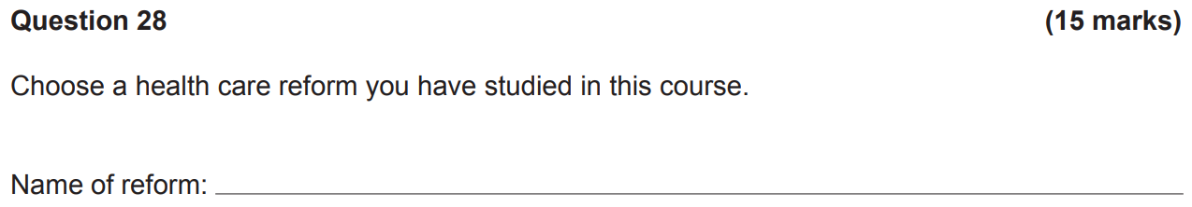

**Pharmaceutical Benefits Scheme (PBS)**



**\*The PBS is a scheme set up by the Australian government which lists medicines subsidised by the government. The main purpose of the PBS is to provide affordable access to necessary medications for eligible Australians. It supports low income earners and concession card holders to access medications at a subsidised price.**



* **Australian residents who hold a current Medicare card.**
* **International visitors from countries from countries that hold a reciprocal agreement with the Australian government.**
* **Pensioners.**
* **Commonwealth Seniors Card holders.**
* **Healthcare Card holders.**
* **Department of Veterans Affairs Card holders.**

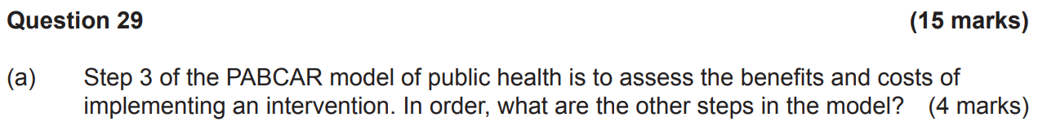

* **Identification of the problem.**
* **Amenability to change.**
* **Acceptability of proposed measures.**
* **Recommended actions and monitoring.**



**Benefits:**

* **A tax could reduce demand/consumption of sugary drinks which contribute to health problems such as obesity and type 2 diabetes which are costly to the community.**
* **Revenue from sugary drink tax could be invested in public health programs.**
* **A sugary drink tax could put pressure on manufacturers to produce healthier drink options.**

**Costs:**

* **There are social consequences attached to taxation e.g., the erosion of consumer’s rights to free choice for activities that don’t bring harm to others.**
* **Implementing a sugar tax could have an impact in some industries if it meant there was reduced consumption of sugary drinks.**
* **Any tax initiative may be seen as unfair/unethical for low-income groups.**
* **Cost associated with implementing a tax and promoting it to the community.**

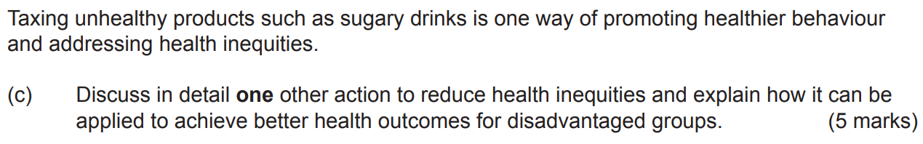

**\*Improving access to healthcare involves ensuring all individuals, regardless of race, ethnicity, gender, socioeconomic status, etc know where to access healthcare and have the means to access healthcare when it’s required to reduce health inequities. This leads to improved health outcomes for these individuals.**

**People living in rural or remote areas have reduced access to many health services. By providing mobile clinics for rural areas, this could improve access to healthcare and reduce health inequities.**

**2017 WACE Exam**

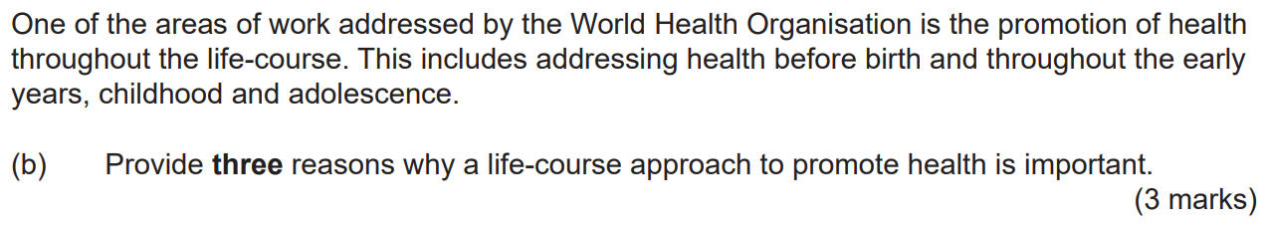

* **Foundations of good health are laid out before birth and in the early years, influencing adult life.**
* **Slow growth and poor emotional support increases the risk of poor health later on life.**
* **Healthy habits (e.g., eating healthy and being active) are best learned in childhood.**
* **It’s easier for children/young people to acquire social and cognitive skills, habits and coping strategies that support good health than it is at older ages.**
* **It focuses on primary prevention – it’s easier to prevent disease than it is to treat/rehabilitate.**
* **It’s a cost-effective approach (particularly in relation to chronic conditions).**

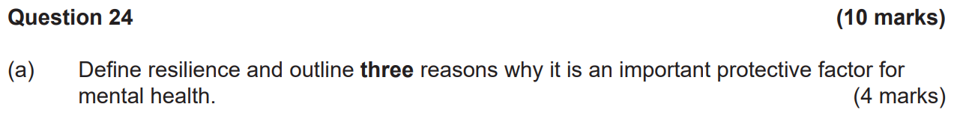

**Resilience: The ability to cope with life’s challenges and adapt to adversity.**

* **Reduces likelihood of engaging in risk-taking behaviours that could have an impact on mental health.**
* **Increases ability to set specific, measurable, achievable, realistic, time-bound goals to focus on and to actively work towards achieving them.**
* **Increases ability to recognise one’s own emotions and take action to cope with setbacks and remain mentally healthy. This could involve learning from previous experiences and better recognising and managing stressors.**
* **Increases ability to make informed decisions, solve problems and take responsibility for one’s own actions.**
* **Increases ability to form and maintain positive relationships with others critical for ensuring good social support.**



**Assertiveness: Standing up for your own personal rights and expressing thoughts, feelings and beliefs in appropriate ways without disrespecting other people’s thoughts, feelings or beliefs.**

**Assertiveness could be used to manage the demand of Year 12 by ensuring that workloads are managed effectively. Candidates could say no with confidence to make sure they don’t overcommit.**

**Stress management: The ability or strategy to cope with stress or turmoil.**

**Stress management could be used to cope with busy times by ensuring that stress management strategies were used to manage stress e.g., breathing and relaxation techniques, positive self-imagery and self-talk.**

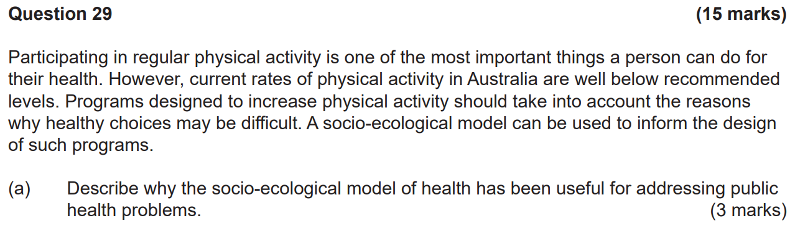

**It’s a conceptual model that outlines how the health status of an individual is influenced by their attitudes, behaviours, relationships, community and society. Each level of the model interrelates with each other and the model aims to understand how factors influence human behaviour for the improvement of health for all individuals.**



**\*Individual:**

**The individual is at the centre of the model. This level involves personal factors/choices that increase or decrease participation in physical activity e.g., knowledge, attitudes, beliefs, perceived barriers, motivation, age, gender, level of education and self-efficacy.**

**Strategy: [Key word is EDUCATION]**

**Interpersonal:**

**This level relates how interpersonal relationships and norms influence behaviour and how they might influence physical activity behaviour.**

**Strategy: [Key word is PARENT/PEER EDUCATION]**

**Organisational:**

**This level relates to how organisations/institutions impact physical activity participation and how practices and policies impact physical activity participation.**

**Strategy: [Key word: WORKPLACE POLICIES/PROGRAMS]**

**Community:**

**This level refers to the broader community context in which people reside and how community influences physical activity levels.**

**Strategy: [Key word: COMMUNITY EDUCATION/SOCIAL MARKETING/PUBLIC AWARENESS/PROMOTION BY THE GOVERNMENT/STRUCTURAL CHANGES IN THE LOCAL ENVIRONMENT]**

**Societal:**

**This level refers to the broader social and political environment which creates a climate in which physical activity is seen to be valuable and is encouraged through policy which supports access and equity for all.**

**Strategy: [Key word is URBAN PLANNING/TRANSPORT POLICIES/SUBSIDIES FOR DISADVANTAGED GROUPS]**

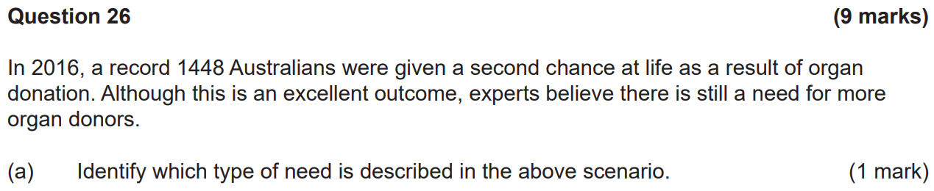

**Normative.**



**Felt need: Needs that an individual or community perceives for themselves.**

**Data can be collected by interacting with the public via surveys, interviews, focus groups and observation.**

**Expressed need: Needs where the felt need is acted on and expressed.**

**Data can be collected through public submissions and data on frequency of health service use.**

**Comparative need: Needs that arise from comparing the needs of populations with similar characteristics that they demonstrated in the same context.**

**Data can be collected by comparing statistics between the different populations using existing data sources.**



* **To identify priority health issues/inequities in a specific population.**
* **To identify the causes of health issues/problems in a specific population.**
* **To identify gaps in services to address identified health issues/inequities.**
* **To determine the most appropriate/effective actions and strategies that could be implemented to target identified needs.**
* **To identify and set goals to improve health issues.**
* **To identify existing resources that could be used to address health issues.**

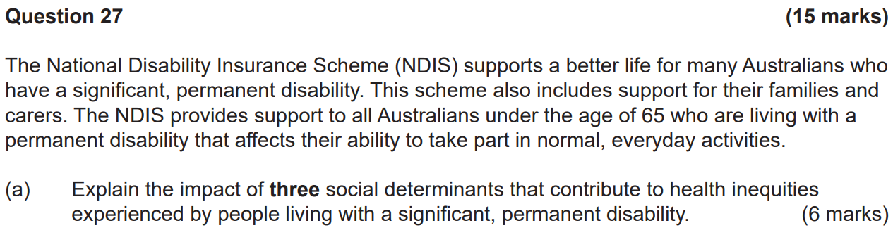

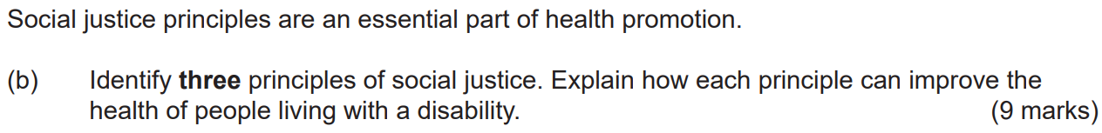

**Access and equity:**

* **Equity means ensuring resources to support PLWD are allocated according to their needs.**
* **Access means ensuring PLWD have appropriate access to healthcare, information and education.**

**Access and equity can improve health:**

* **By ensuring PLWD have the opportunity to be involved in planning and decision-making in about their health.**
* **By ensuring priority groups are given adequate funding to improve health outcomes.**
* **By ensuring equal access to resources regardless of the nature of the disability.**
* **By ensuring PLWD are allocated resources based on their needs.**

**Diversity:**

* **This refers to ensuring that information and healthcare are relevant and appropriate for all people, including PLWD.**

**Diversity can improve health:**

* **By ensuring differences between the types of disability are considered in decision making.**
* **By being flexible/adaptable instead of using a one-size-fits-all approach.**
* **By adopting personalised and meaningful approaches to acknowledge the range of disability.**

**Supportive environments:**

* **This includes environments in which people live and work and how they protect people from threats to health and encourage healthy behaviour.**

**Supportive environments can improve health:**

* **By providing opportunities for healthy choices and behaviour by making community facilities available (e.g., ramps, railings, etc) to encourage engagement in community activity and opportunities for physical activity.**
* **By providing opportunities for involvement with health services e.g., making facilities more accessible.**
* **The provision of the NDIS which gives financial incentives to PLWD, which could allow for greater independence and involvement within the community, hence leading to improvements in mental health.**

**2018 WACE Exam**

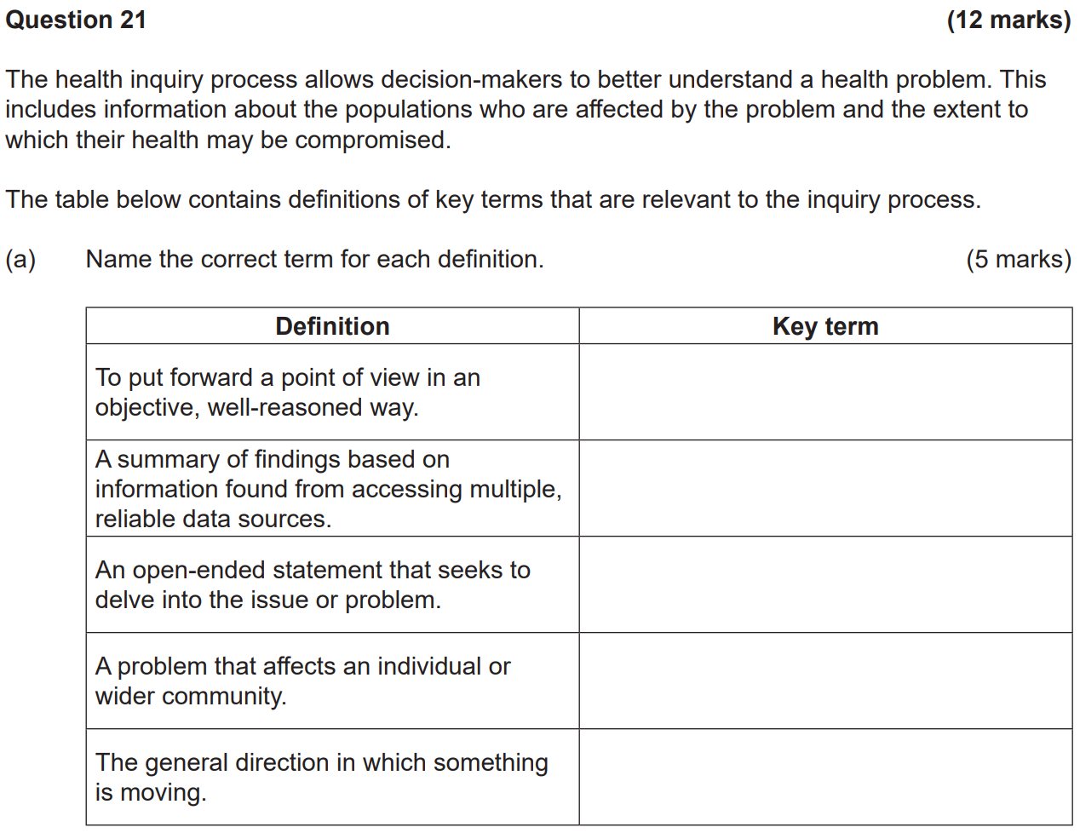

**Argument**

**Conclusion**

**Focus question**

**Health issue**

**Trend**

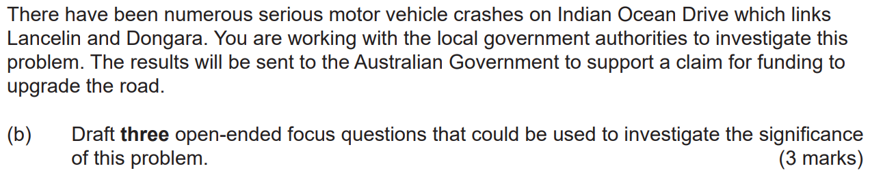

* **What’s the impact of road crashes on the families of those killed or injured?**
* **What are the costs associated with a road crash?**
* **Which groups of people are affected when a car crash occurs?**
* **How does the impact of car crashes contribute to health inequity?**

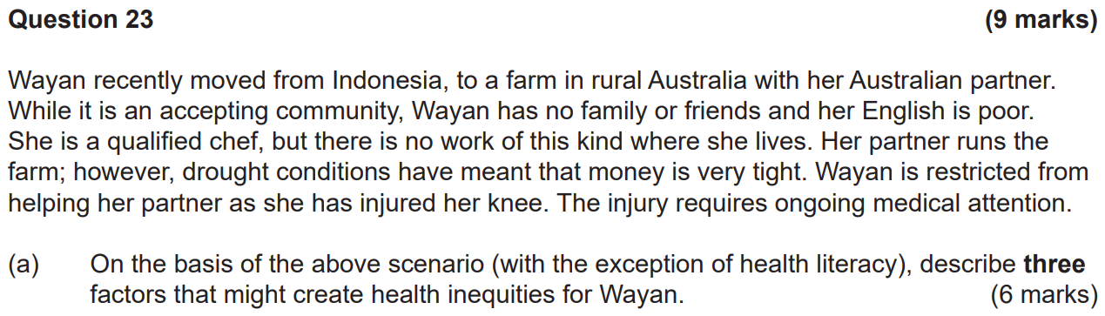

**Access to healthcare:**

**Wayan may not be able to access specialist treatment for her knee injury. This may impact her ability to work and access transport, thus contributing to isolation.**

**Unemployment:**

**Given that there’s no work for Wayan in the community, this may impact on her level of income which is related to economic security, ability to access healthcare and socioeconomic status.**

**Social isolation:**

**Living in a farm in rural Australia may reduce opportunities to socialise and connect with the community. Being unable to work may contribute further to social isolation.**

**Occupation:**

**Wayan is restricted in completing farm duties due to her knee injury. This may decrease the farm’s profitability or work output, or other workers need to be paid, thus reducing income.**

**Access to and level of education:**

**Living in a rural area may restrict opportunities to re-train or develop skills in another area where there may be more opportunities to gain employment.**

**Geographic location:**

**People living in rural areas generally experience poorer health outcomes than people living in urban areas where there’s sufficient health services.**

**Socioeconomic status:**

**Wayan may experience poor socioeconomic circumstances if she doesn’t find work and/or if the farm were to suffer (money is already tight).**

**Government economic and social policies:**

**Being in a rural area means that governments may not provide adequate health services for the community.**

**(Note: Poor language skills doesn’t mean poor health literacy)**



* **Could have problems identifying which health services are necessary for her ongoing care.**
* **Could have difficulty understanding instructions given by healthcare professionals.**
* **May have problems finding health information.**
* **May have problems processing and interpreting health information.**
* **Poor ability to scrutinise health information and determine whether information is reliable or not.**
* **May have difficulty in effectively interacting with health professionals to have her questions answered and needs met.**
* **Poor ability to communicate her health needs to others.**
* **May have difficulty in accessing work opportunities and/or social support.**

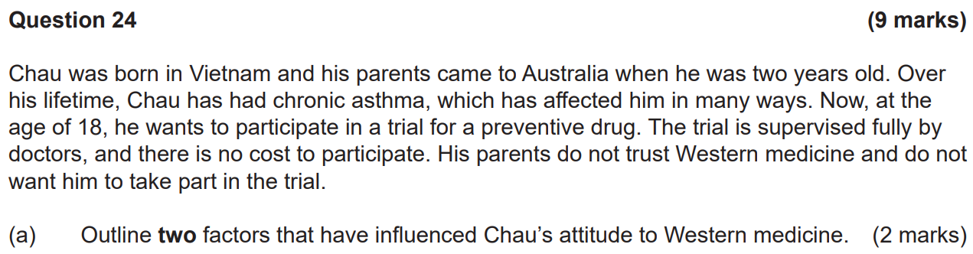

* **Has grown up in Australia and is familiar with the Australian healthcare system and has trust and confidence in it.**
* **Has a sufficient level of health literacy to understand the benefits and risks of participating in the trial.**



**Assertiveness means standing up for your own personal rights and expressing thoughts, feelings and beliefs without disrespecting other people’s thoughts, feelings or beliefs.**

**Chau could express his thoughts, feelings and beliefs in a calm manner and reassure his parents that he considers and respects their thoughts, feelings and beliefs. Carefully outlining his reasons for participating in the trial in a way that’s understandable to his parents may also help.**

**Stress management refers to techniques and strategies which enable a person to use effective coping mechanisms to deal with stress. Chau could acknowledge that his wishes may cause grief upon his parents and should this upset him, he could apply techniques (e.g., controlled breathing and visualisation) to prevent and minimise stress.**

**Resilience is the ability to cope with life’s challenges and to adapt to adversity. Chau could persuade his parents to allow him to participate despite setbacks or challenges from his parents that may occur along the way.**

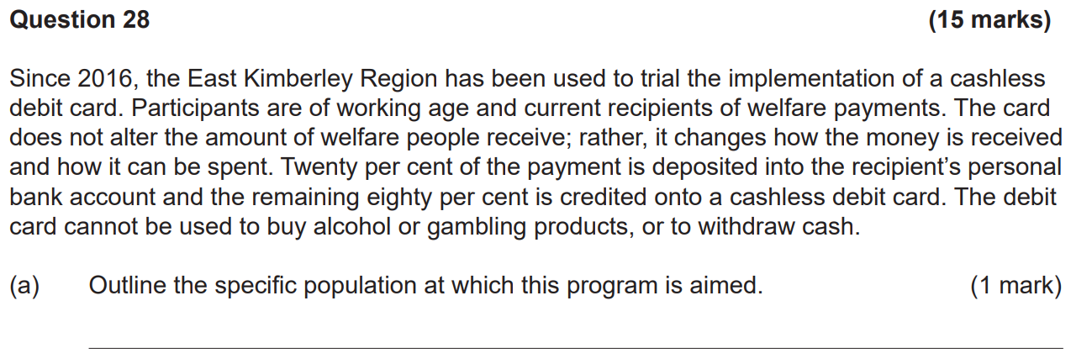

**People who receive welfare payments.**



**For:**

* **It’s a useful tool in addressing the devastating impacts of problematic alcohol use and gambling.**
* **It reduces the risk of foetal alcohol syndrome in the community.**
* **It reduces the strain on the health system due to lower incidence of diseases or injuries as a result of problematic alcohol use and gambling.**

**Against:**

* **It takes control of spending away from welfare payments – it doesn’t foster empowerment or allow individuals to make healthier choices.**
* **Without other measures to support the use of the card, the intervention may not work as individuals may resort to other ways to purchase alcohol or gamble.**
* **It may increase the crime rate in the area due to individuals using other means to acquire alcohol or money for gambling.**



**[1] What’s the problem and why is it significant?**

**The problem is that socioeconomically disadvantaged groups are suffering poor health outcomes as a result of problematic alcohol use and gambling. The community is subject to problems associated with alcohol abuse (e.g., domestic abuse and foetal alcohol syndrome) and not having their basic needs catered for.**

**[2] Is the problem amenable to change?**

**Research could be done to determine the outcomes of such an intervention in other communities where the welfare card has been introduced. Data e.g., hospital admissions and school attendance should be collected and examined.**

**[3] Are the intervention benefits greater than the costs?**

**A cost-benefit analysis could be undertaken to determine the potential advantages and disadvantages related to implementing the welfare card. If the benefits outweigh the costs, them the intervention should be considered.**

**[4] What’s the acceptability of the proposed measures?**

**Consider community attitudes and frame arguments to gain the most support for the intervention. This aims to consider opposition to the welfare card and mobilise support. If support for the intervention isn’t significant then advocacy strategies may be required.**

**[5] Recommended actions and monitoring.**

**Consideration of recommended actions for successful implementation of the welfare card and development of strategies to monitor such actions.**

**2019 WACE Exam**

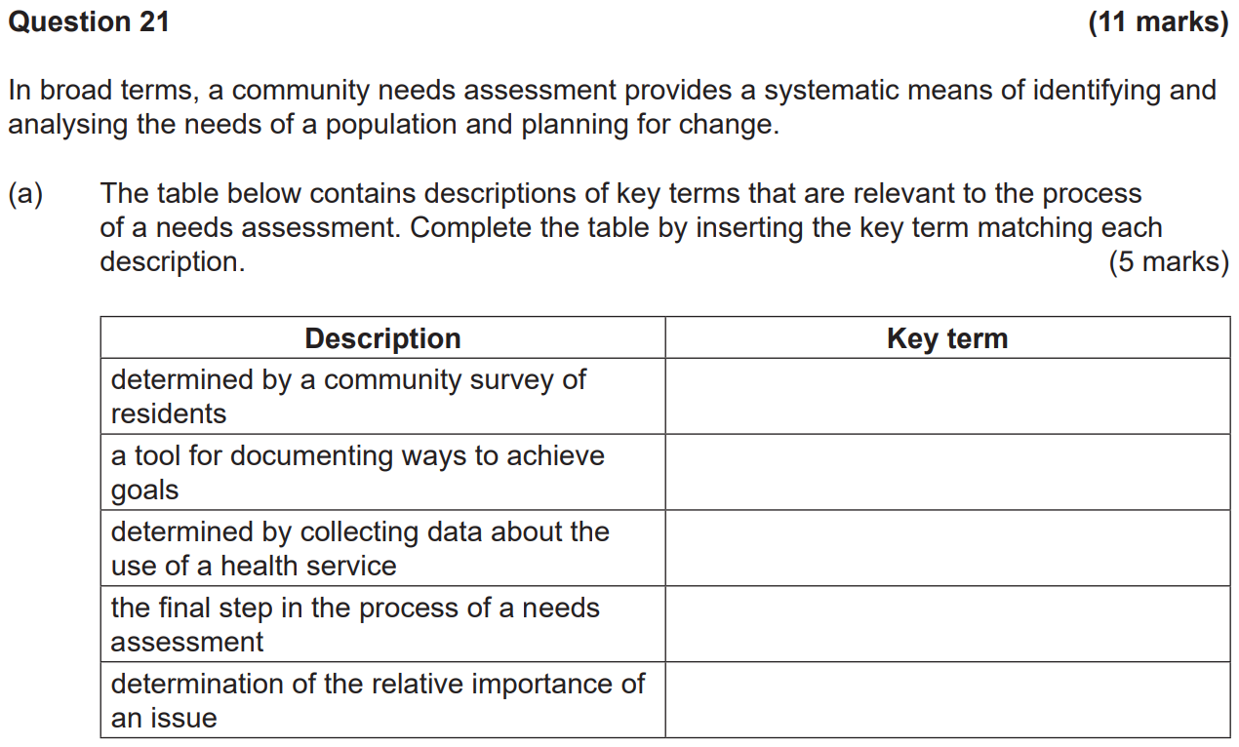

**Felt need.**

**Action plan.**

**\*Expressed need.**

**Evaluating outcomes.**

**Prioritising issues.**

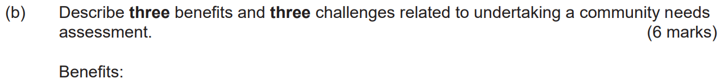

**Benefits:**

* **Allows for the opportunity to clearly analyse the health issue in question.**
* **Allows for prioritisation of health issues.**
* **Can inform the design of relevant interventions.**
* **Provides data to inform decisions.**
* **Provides documentation/case studies to record what has happened in the past so that others can learn from previous needs assessments.**
* **Allows for better/more efficient use of resources.**

**Challenges:**

* **May be difficult to determine the exact needs due to underreporting e.g., drug use.**
* **Resistance to change by the community.**
* **It’s difficult to see value in the process where change is slow.**
* **It requires expertise and resources which the community may not have.**
* **It’s difficult to maintain commitment from the community, especially where change isn’t visible.**
* **May be difficult to ensure an unbiased, broad range of views is collected.**



* **To reduce the impacts of poor health for communities.**
* **To reduce disease spreading quickly and intervene early. Early detection means the disease can be treated before it gets worse.**
* **To improve social justice and equity as disadvantaged groups are able to access services for free or at a low(er) cost.**
* **To provide vital medicines for all Australians with very little cost (through the PBS).**
* **To encourage high income earners to pay for private health insurance, reducing pressure on the public system (through the private health insurance rebate).**
* **To encourage people to access preventive services e.g., screening and immunisations.**

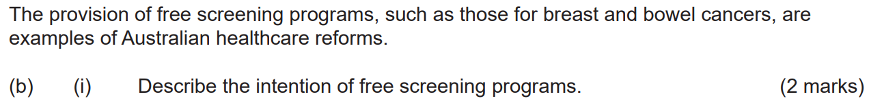

**Free screening programs are available/accessible for all Australians. The intention of this reform is to encourage Australians to take up or continue with screening which is an early strategy targeted at reducing health inequities and reducing deaths through early detection. The barrier of cost is removed. This may contribute to a reduction in advanced cancer diagnoses, reducing the burden of disease and pressure on public health resources associated with tertiary treatments.**



**Free screening programs aim to deliver an equitable healthcare system because they remove barriers of access and support access to screening services by all individuals regardless of factors e.g., race, ethnicity, socioeconomic status, etc. This supports all Australians to access preventive public healthcare in a timely and affordable manner and in ways that are culturally appropriate and considerate of personal needs.**

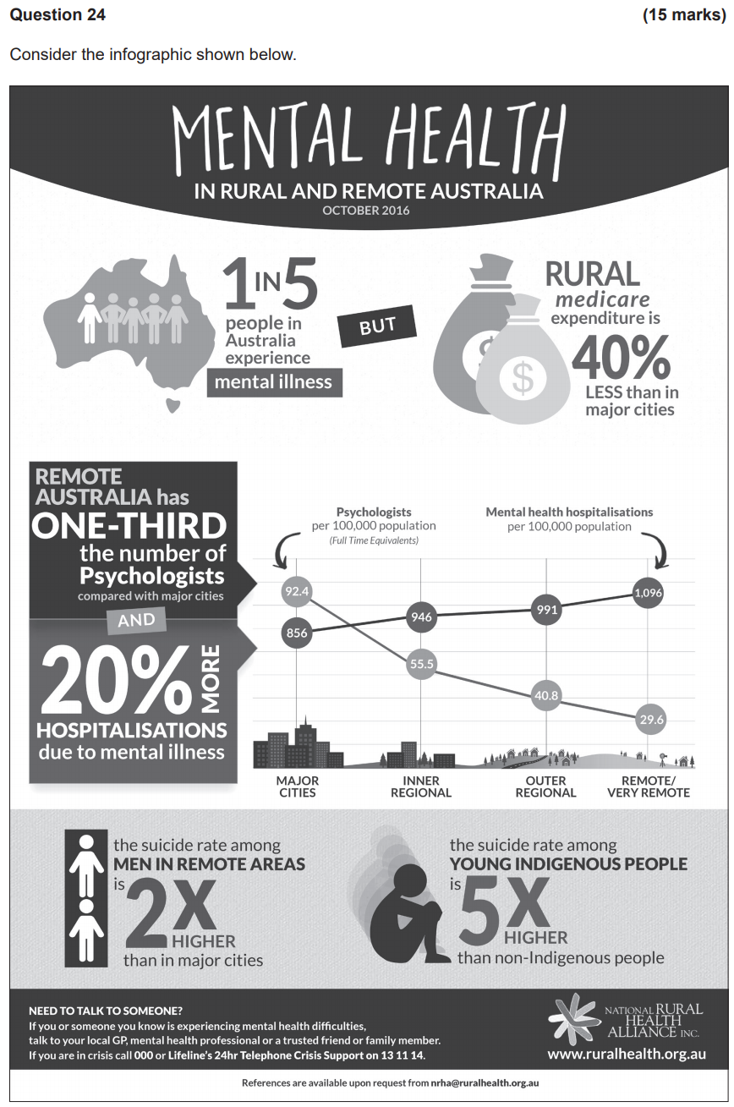



**Quantitative.**



**[Write the statistics]**



* **The data doesn’t provide reasons for why the inequities occur. It only provides statistics of percentage of people affected and lack of services in remote areas.**
* **Examining multiple sources provides the opportunity to identify corroborating or conflicting information, establishing a more accurate and evidence-based assessment of the issue.**
* **The data presented doesn’t provide data on how it’s been collected e.g., sample size of a survey.**
* **Other than hospitalisations, the data narrows in on men and young Indigenous people, thus not giving a full picture of others in the community.**



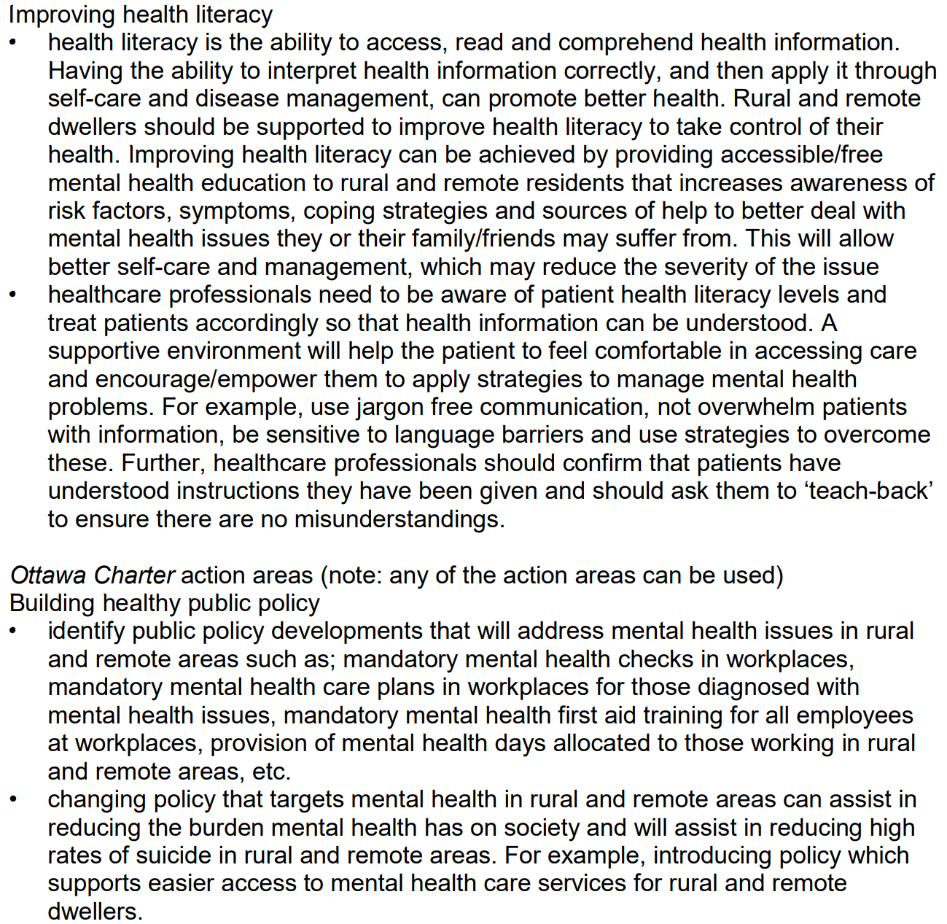

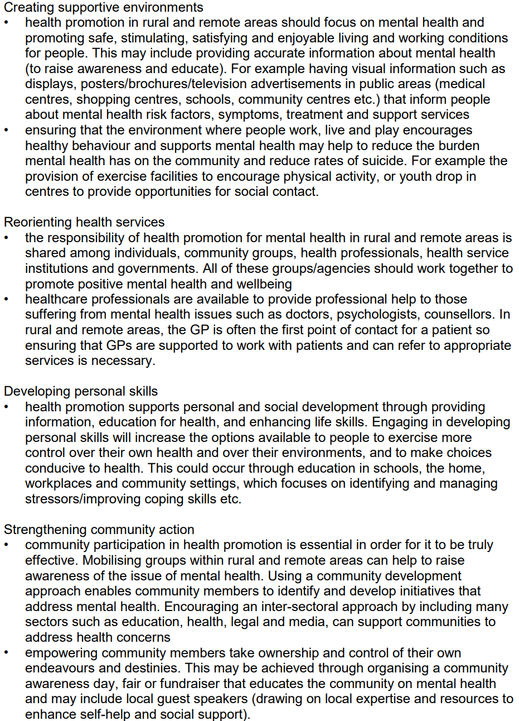

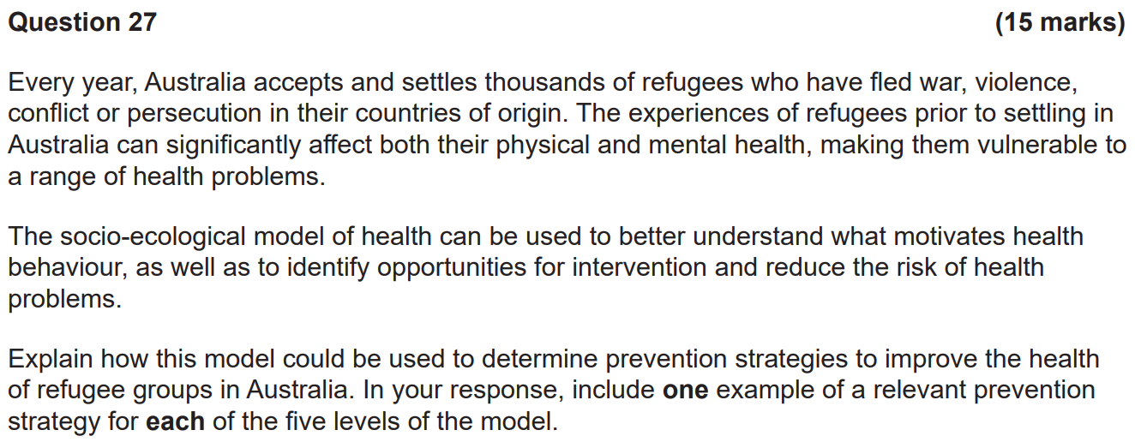

**Individual: The individual is at the centre of the model. This level involves personal factors that could increase or decrease refugees’ susceptibility to health problems e.g., attitudes, knowledge, behaviours, perceived barriers, motivation, age, gender, level of education and self-efficacy.**

**Strategy: Education explaining coping strategies to effectively deal with stress as a result of their past.**

**Interpersonal: This level relates to the impact of interpersonal relationships and norms on behaviour and how this might impact refugees’ susceptibility to health problems.**

**Strategy: Education to peers of refugees explaining the common stressors of refugees who have fled from war, conflict, violence or persecution.**

**Organisational: This level relates to how organisations/institutions impact refugees’ susceptibility to health problems and how practices and policies can support refugees’ health.**

**Strategy: Workplaces could provide counselling services, reducing the impact of trauma.**

**Community: This level refers to the broader community context in which people reside and how communities can influence refugees’ health.**

**Societal: This level refers to the broader social and political environment which creates a climate where refugees are recognised as a disadvantaged group and is encouraged through policy which supports access and equity for all.**

**Strategy: Government provides subsidies for refugees fleeing violence, conflict, war or persecution as they have generally lower income and socioeconomic status.**

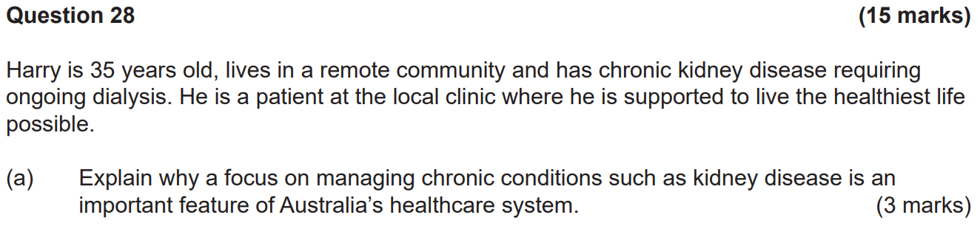

**The ability to effectively manage chronic conditions eases pressure on an already overburdened healthcare system. This allows for healthcare systems to focus more on injured patients and patients who are unable to manage their conditions, improving health for all individuals.**

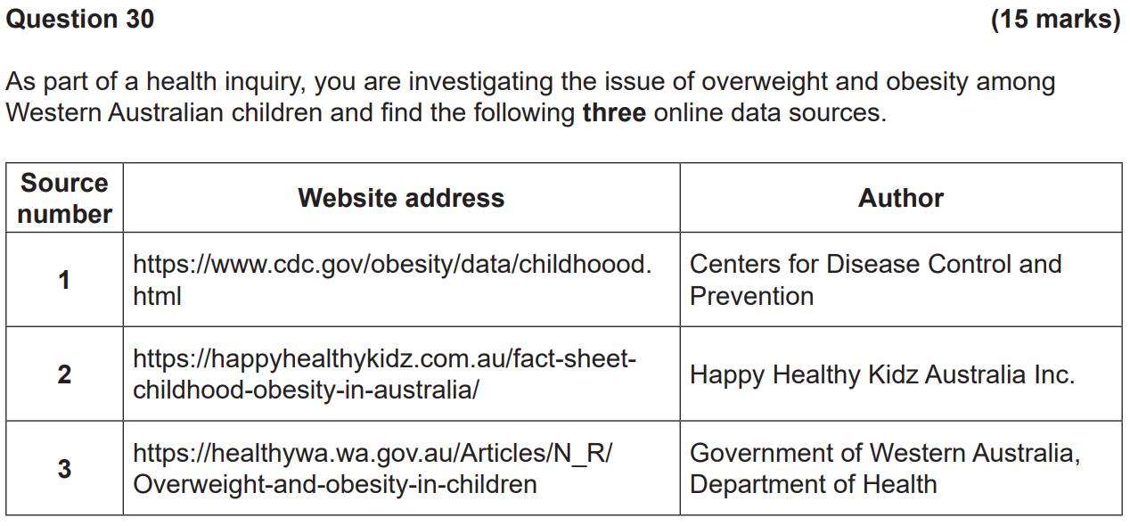



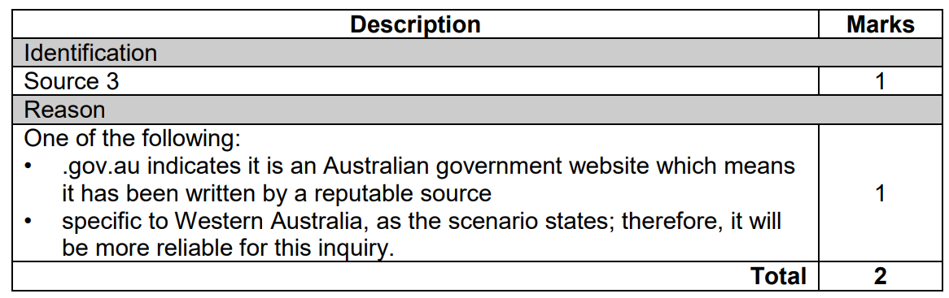



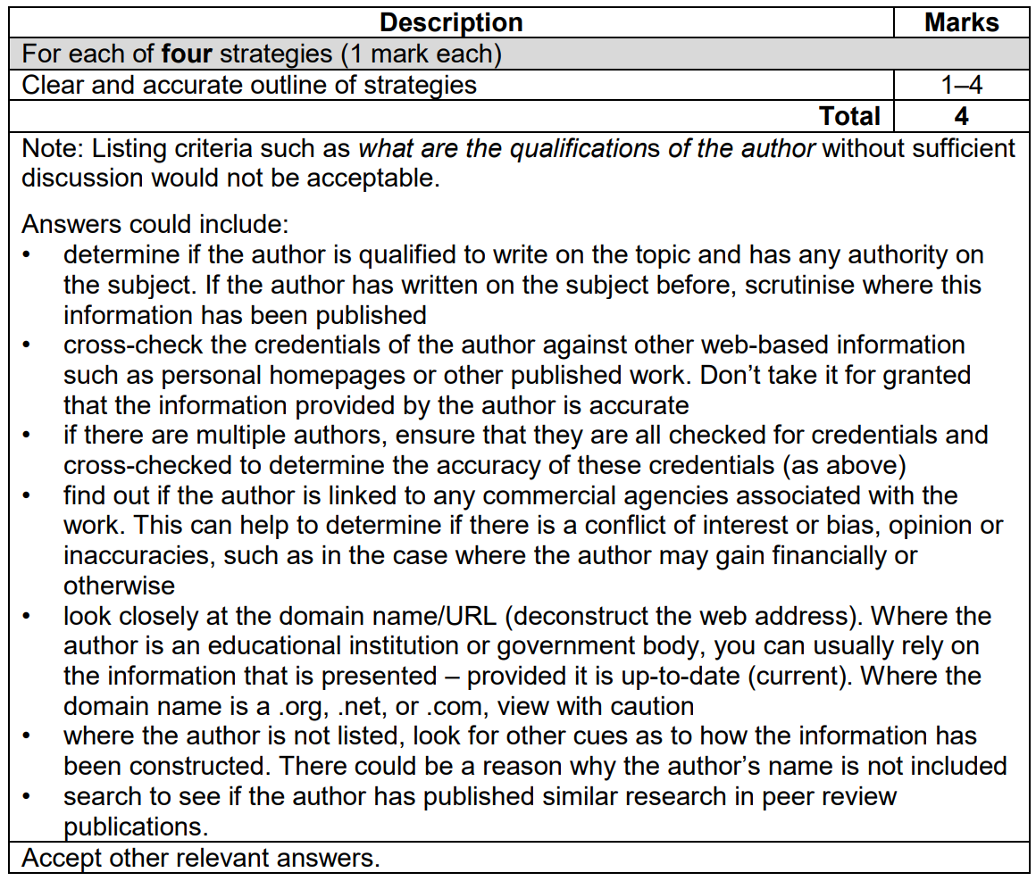



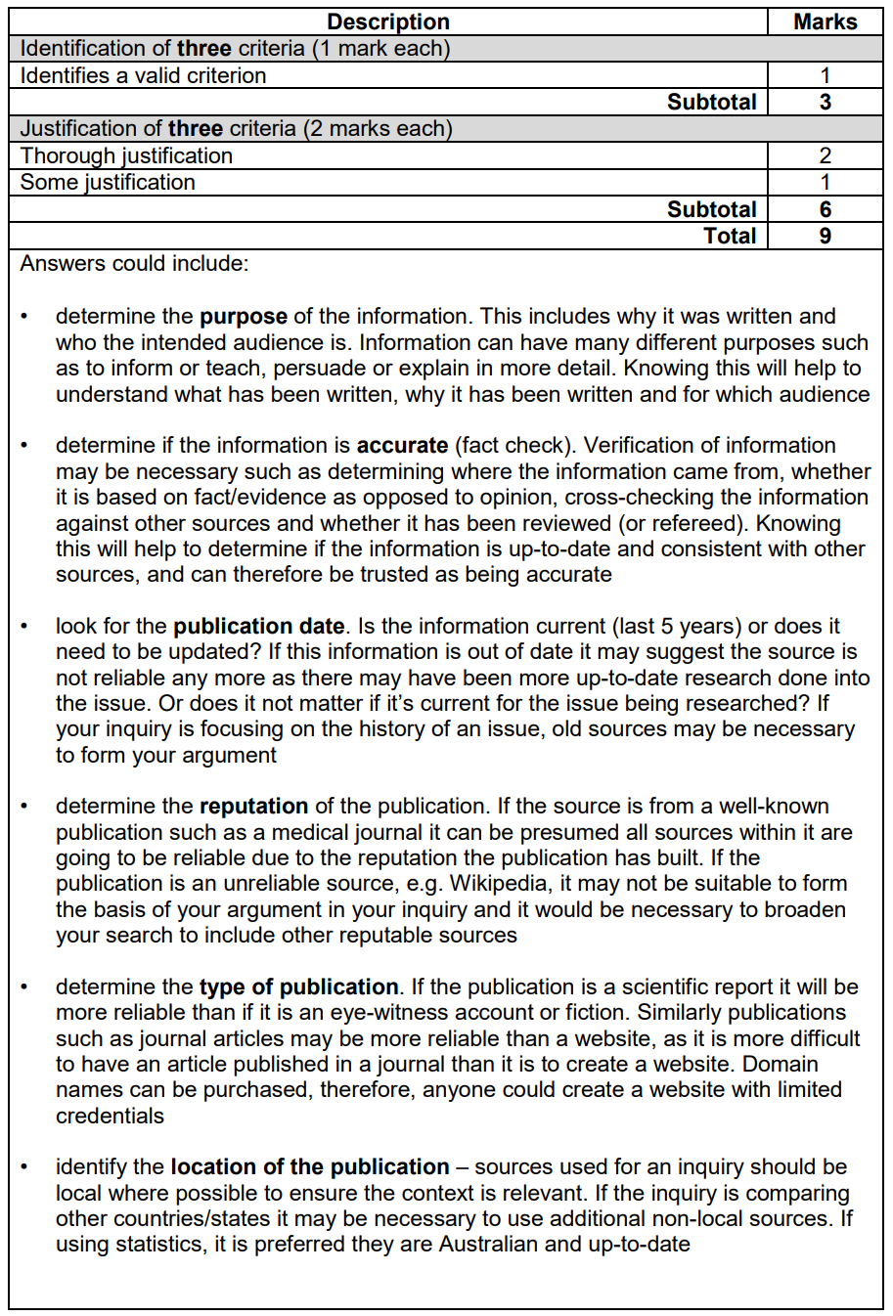

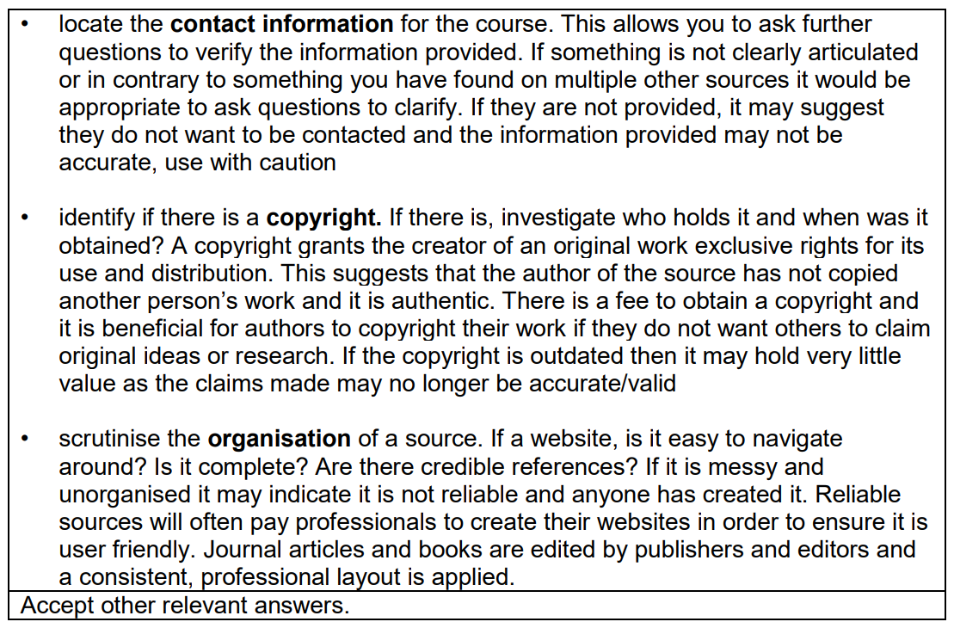

**2020 WACE Exam**

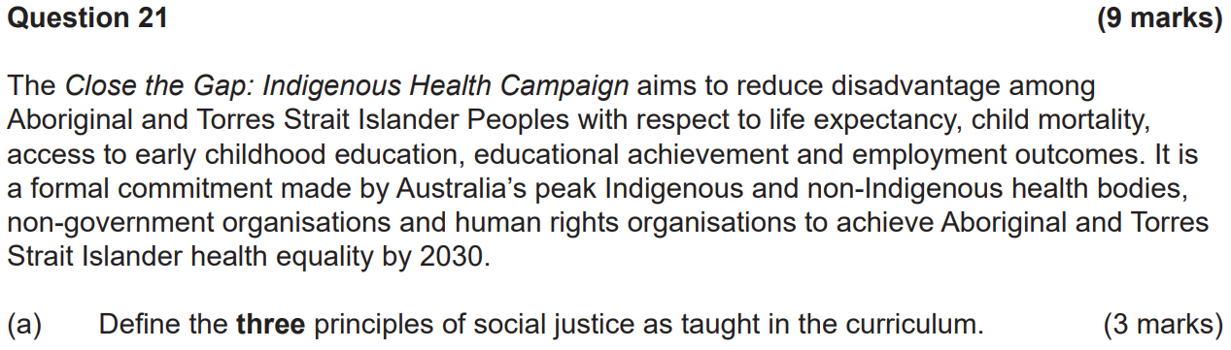

**Access and equity: Ensuring resources and services are allocated according to the needs of specific populations with the goal of equality of health outcomes. This allows for a more balanced level of access for all and equitable allocation of funding and essential resources.**

**Diversity: Respecting differences that exist between individuals and groups, especially when it comes to addressing healthcare and good health outcomes. This involves acknowledging that certain populations require diverse resources and healthcare.**

**Supportive environments: Environments where people live, work and play that protect people from threats to their health. These environments can be supportive in encouraging practices to achieve optimum levels of health.**



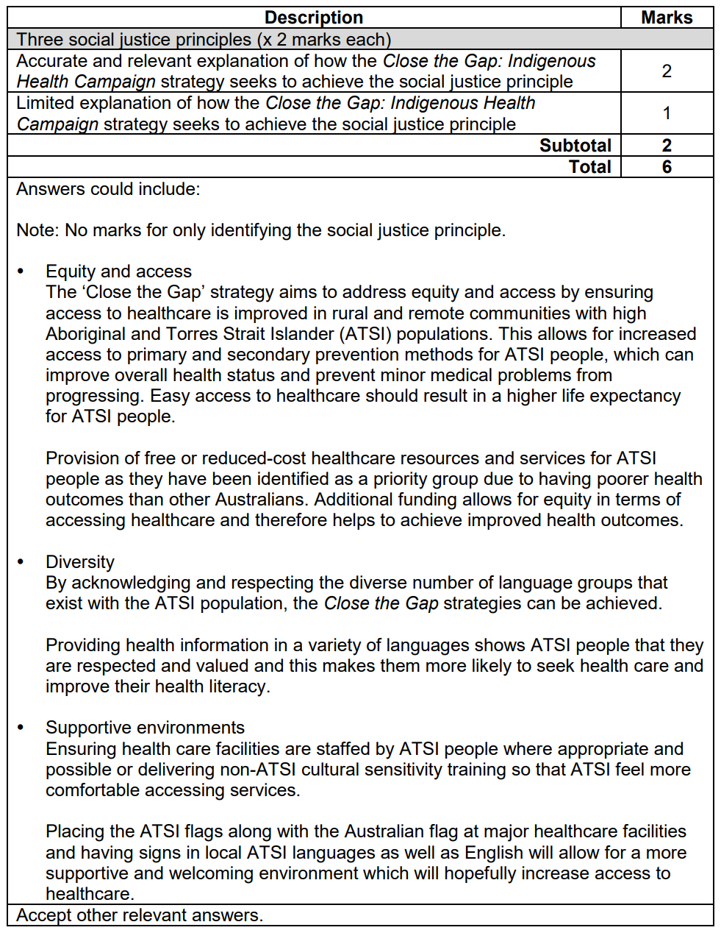

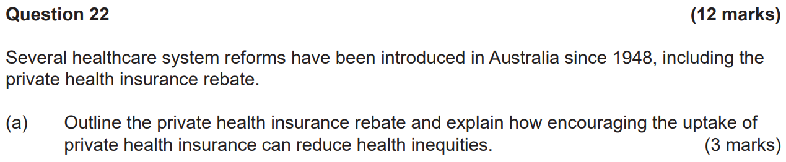

**The private health insurance rebate is an amount that the government contributes to the cost of your private health insurance premiums. It reduces the uptake of public health insurance, reducing pressure on the public health system and allowing for lower socioeconomic individuals to access health service more readily.**

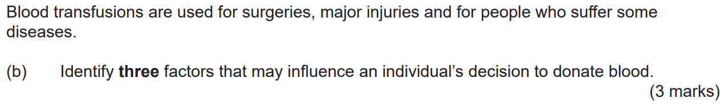

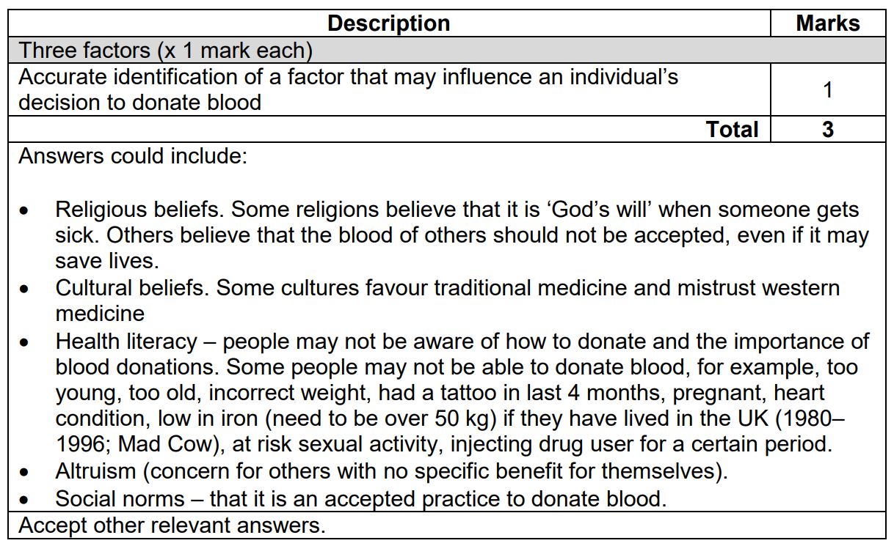

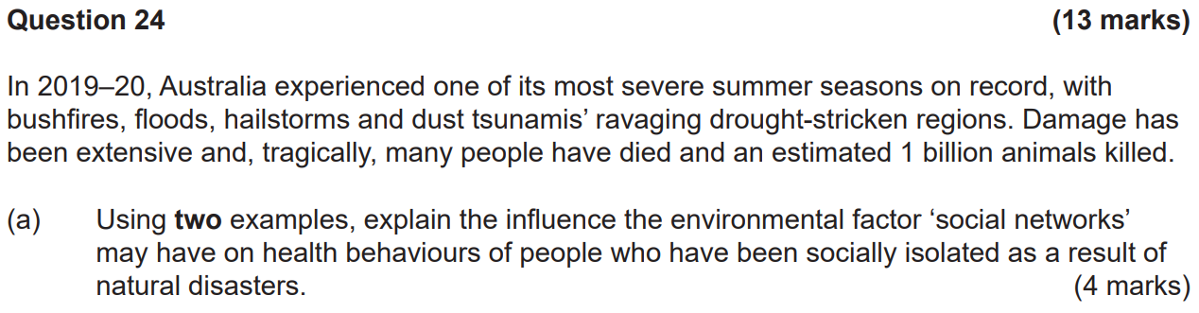

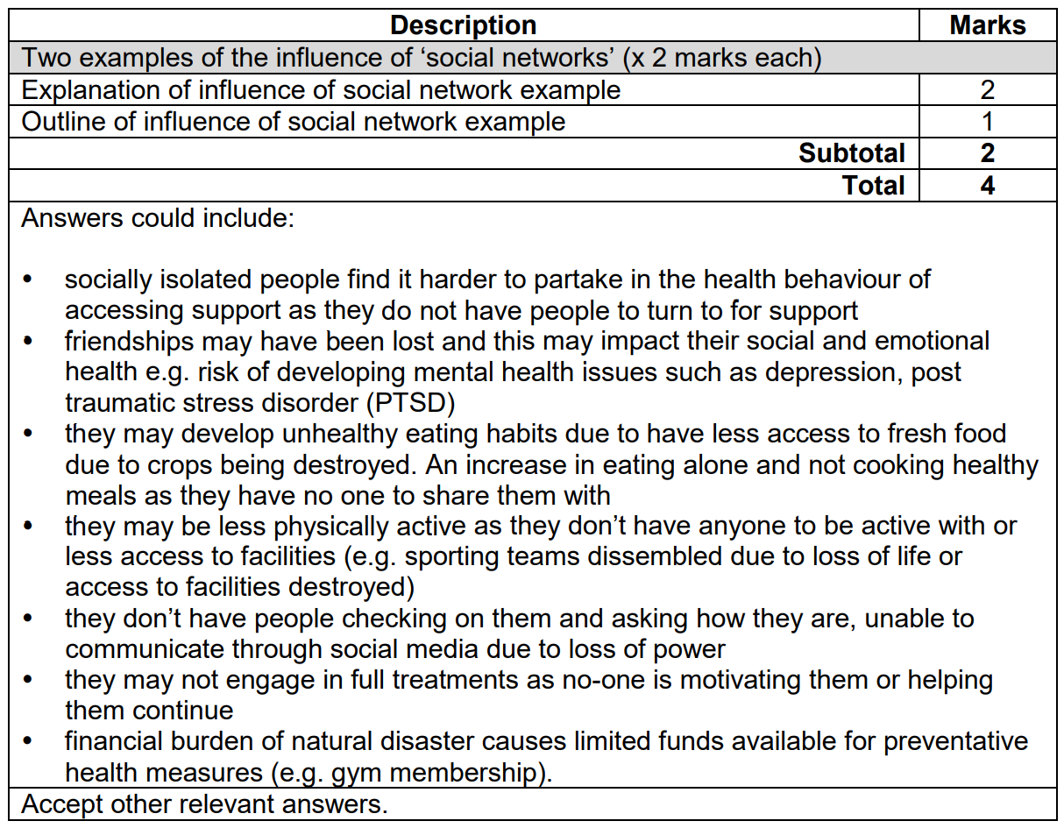

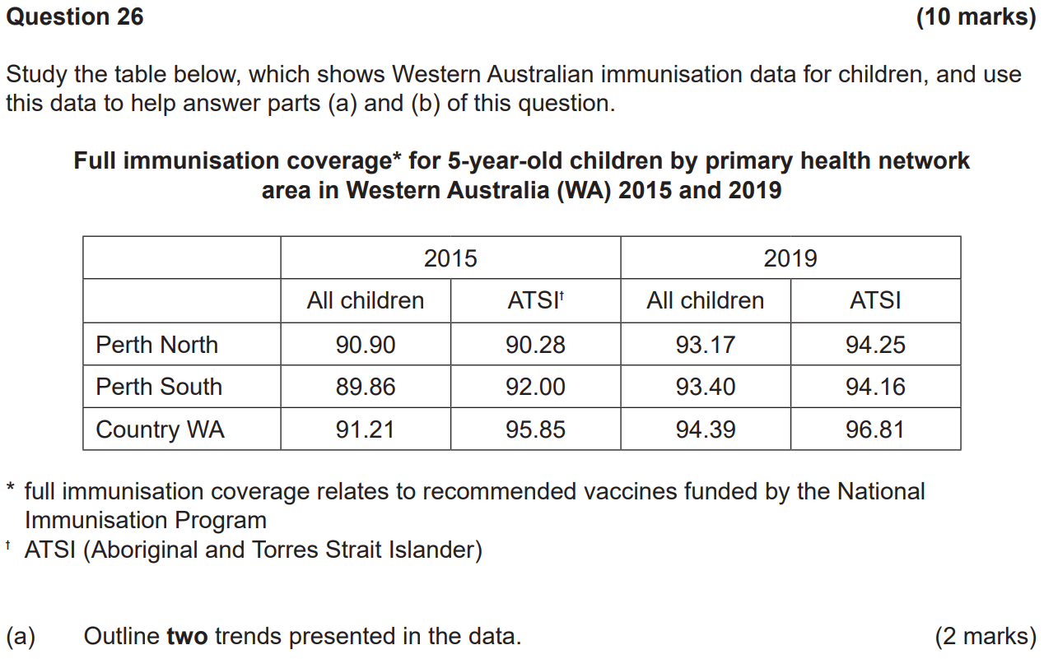

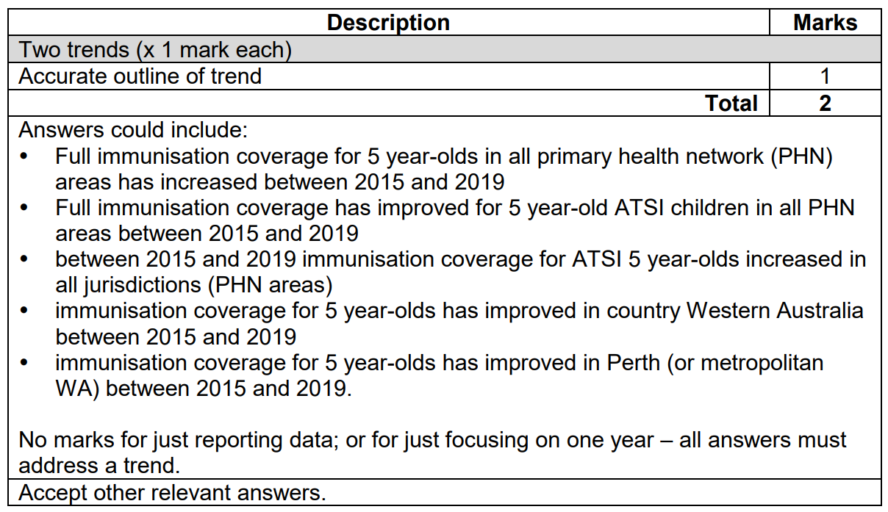



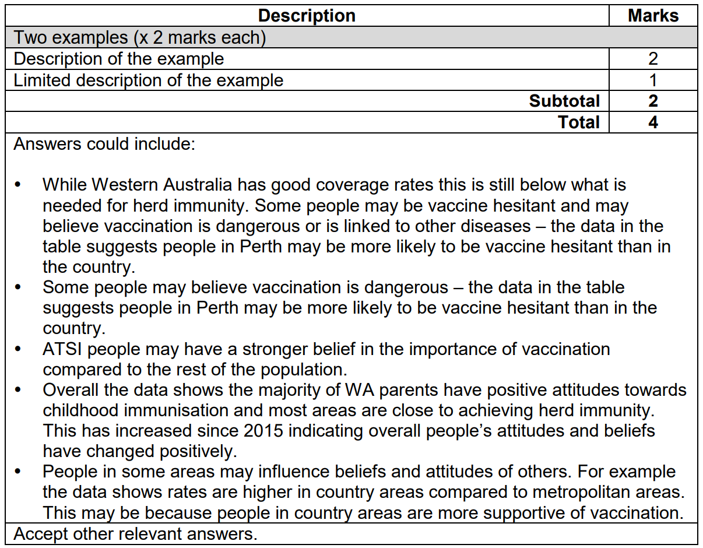



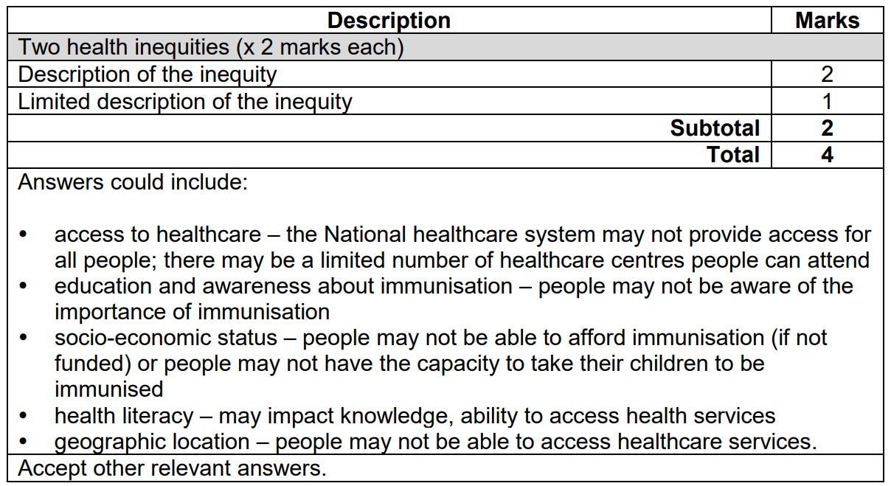

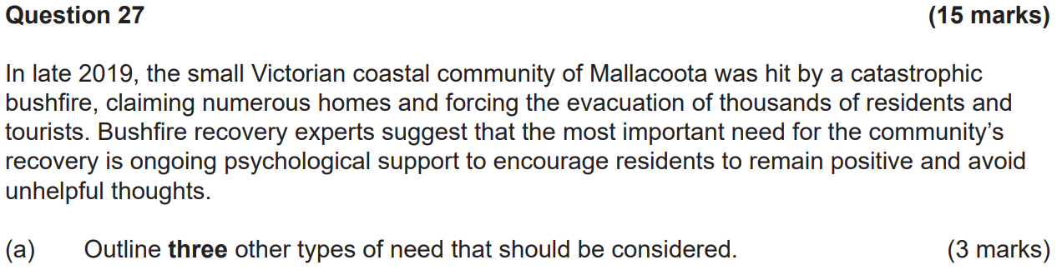

**Felt need: The needs that an individual or group perceives for themselves. These needs can be determined by asking the Mallacoota community what they feel like they need to recover from the bushfire.**

**Expressed: Felt needs become expressed needs when people put what they want into action. This can be determined by analysing waiting lists for hospital admissions.**

**Comparative need: Needs determined by comparing the needs of a population with similar characteristics that they demonstrated in the same context. The needs for recovery services could be based on other fire-affected communities without collecting data from Mallacoota.**

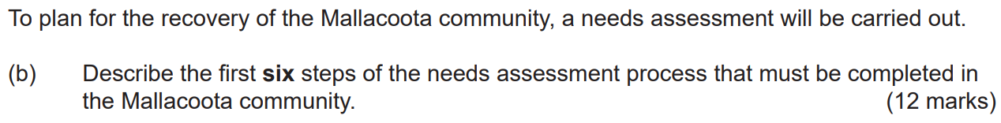

**Identifying health issues:**

**This stage involves collecting information surrounding the key health issues facing the Mallacoota community. Health issues may be determined by social, political, economic and environmental determinants. This stage should explore which members of the community will be included in the process. The different types of need that demand action will be researched. Health issues for may be determined by accessing local data (e.g., healthcare service use) and by talking to local people.**

**Analysis of the problem:**

**This stage involves an in-depth analysis of the characteristics of the population, how it differs to other populations and gathering relevant data. This may include health status data, access to services, availability of services, etc. Local data can be compared with State and National data to determine the extent of the problem.**

**Prioritising health issues:**

**Key health issues should be considered and prioritised. Prioritisation may be based on those with the most significant impact, amenability to change and available resources. Input from the Mallacoota community should be considered at this stage.**

**Setting goals:**

**Once the community determines the most significant health issues, specific, measurable, achievable, realistic, time-bound goals must be set to achieve the best possible outcomes for the Mallacoota community.**

**Determining strategies:**

**This stage involves using an effective decision-making model to determine the most effective course of action. To determine the best strategy, the needs assessment team could research other communities that have been affected with the same circumstances and what worked effectively for them.**

**Developing action plans:**

**Once the most effective strategies have been determined, the needs assessment team will develop an action plan to put them into place. This involves producing a detailed plan of what needs to be done by who and when. Adhering to a timeline allows for the action plan to be most effective in achieving the best outcomes for the Mallacoota community.**